|  |  |
| --- | --- |
| **Ex. No. 7** | **Website Design with JQuery Actions** |
| **Date of Exercise** | 18-09-2022 |
| **Web Host Link** | <https://ysriganesh.github.io/webapp/web%207/exp71.html>  <https://ysriganesh.github.io/webapp/exp-7/first.html> |
| **Youtube Link** |  |

**Aim**

To create a web page using HTML, CSS and JQuery actions.

**Description**

<!DOCTYPE>- It is an information to the browser about what document type to expect. The

syntax is <!DOCTYPE html>

<html> </html>- The <html> tag represents the root of an HTML document and it is the

container for all other HTML elements.

headings- HTML headings are defined with the <h1> to <h6> tags. The <h1> defines the most

important heading and <h6> tag depicts the least important heading.

image- The <img> tag is used to embed in an image in the html page. Images are linked to

theweb pages.

anchor- The <a> tag defines the hyperlink which is used to link one page from another. The

most important attribute is href attribute that indicates the destination of the link.

title- The <title> tag defines the title of the document. It is displayed in the title bar of the

browser or in the tab of the page.

head- The <head> element is a container for meta data and is placed between the <html> tag and

the<body> tag.

body- The <body> tag defines the body of the document. It contains all of the contents of an

html document such as headings, paragraph, hyperlinks, images, lists and tables etc.

input tag- The <input> tag specifies an input field where the user can enter data.

The $(document).ready() method is used to execute a function when the document is fully

loaded.

The click() method attaches an event handler function to an HTML element.

The jQuery #id selector uses the id attribute of an HTML tag to find the specific element.

The jQuery .class selector finds elements with a specific class.

animate()- method is used to create custom animations.

Function – A JavaScript function is a block of code designed to perform a particular task.

Id – The HTML id attribute is used to specify a unique id for an HTML element.

<h1> -The <h1> tag defines the most important heading. It should be used for main headings.

<div> tag- defines a division or a section in an HTML document. It is used as a container

forHTML elements.

**Program**

<!DOCTYPE html>

<html lang="en">

<head>

    <meta name="viewport" content="width=device-width, initial-scale=1.0">

    <script src="https://ajax.googleapis.com/ajax/libs/jquery/3.6.0/jquery.min.js"></script>

    <link rel="stylesheet" href="expe7.css">

    <script>

        $(document).ready(function () {

            $('#b1').click(function () {

                let d1 = $('#t1').val();

                let m1 = $('#t2').val();

                let y1 = $('#t3').val();

                let date = new Date();

                let d2 = date.getDate();

                let m2 = 1 + date.getMonth();

                let y2 = date.getFullYear();

                let month = [31, 28, 31, 30, 31, 30, 31, 31, 30, 31, 30, 31];

                if (d1 > d2) {

                    d2 = d2 + month[m2 - 1];

                    m2 = m2 - 1;

                }

                if (m1 > m2) {

                    m2 = m2 + 12;

                    y2 = y2 - 1;

                }

                let d = d2 - d1;

                let m = m2 - m1;

                let y = y2 - y1;

                $('#box').html("Age Details ");

                $('#result').html(+y + " years " + m + " months " + d + " days")

            })

        })

    </script>

    <title>Document</title>

</head>

<body>

    <div id="d1">Age Calculator</div>

    <div id="d2">Enter the Birth Date</div>

    <p>Day <br><input id="t1" type="text"></p><br>

    <p>Months <br><input id="t2" type="text"></p><br>

    <p>Years <br><input id="t3" type="text"></p><br>

    <button id="b1">Final Age</button><br><br>

    <hr>

    <hr>

    <br><br>

    <div id="box"></div>

    <div id="result" type="text" readonly></div>

</body>

</html>

Secound Question:

<html>

<head>

    <title>Car Racing Game In jQuery</title>

    <script src="https://ajax.googleapis.com/ajax/libs/jquery/3.6.0/jquery.min.js"></script>

    <link rel="stylesheet" href="stylesheet.css">

    <script>

        $(document).ready(function(){

        $('#Go').click(function(){

    function CheckIfComplete() {

        if (isComplete == false) {

            isComplete == true;

        } else {

            Place = 'Second';

        }

    }

    var CarWidth = $('#Car1').width();

    var RaceTrackWidth = $(window).width() - CarWidth;

    var RaceTime1 = Math.floor((Math.random() * 5000) + 1);

    var RaceTime2 = Math.floor((Math.random() * 5000) + 1);

    var isComplete = false;

    var Place = 'First';

    $('#Car1').animate({

        left: RaceTrackWidth

    }, RaceTime1, function() {

        CheckIfComplete();

        $('#RaceInfo1 span').text('Finished in ' + Place + ' place & Clocked in at ' + RaceTime1 + ' ms');

    });

    $('#Car2').animate({

        left: RaceTrackWidth

    }, RaceTime2, function() {

        CheckIfComplete();

        $('#RaceInfo2 span').text('Finished in ' + Place + ' place & Clocked in at ' + RaceTime2 + ' ms');

    });

    $('#Reset').click(function() {

        $('.Car').css('left', '0');

        $('.RaceInfo span').text("");

    });

})

});

    </script>

</head>

<body id="Race">

    <h1>jQuery Car Racer</h1>

    <input type="button" value="Race" id="Go">

    <input type="button" value="Reset" id="Reset">

    <div id="RaceTrack">

        <img width="15%" id="Car1" class="Car" src="https://image.shutterstock.com/image-photo/studio-shot-colorful-toy-car-260nw-60699184.jpg" alt="Green Car">

        <img width="15%" id="Car2" class="Car" src="https://image.shutterstock.com/image-vector/toy-car-cartoon-vector-illustration-260nw-636992845.jpg" alt="Red Car">

    </div>

    <div id="RaceInfoCntnr" class="ClearFix">

        <h2>Results</h2>

        <div id="RaceInfo1" class="RaceInfo">Car 1 <span></span>

        </div>

        <div id="RaceInfo2" class="RaceInfo">Car 2 <span></span>

        </div>

    </div>

    <!--Load CDN First-->

    <script src="https://ajax.googleapis.com/ajax/libs/jquery/3.6.0/jquery.min.js"></script>

    <!--If CDN Fails to load, serve up the local version-->

    <script>

        window.jQuery || document.write('<script src="jQuery.js"><\/script>');

    </script>

</body>

</html>

**Output**

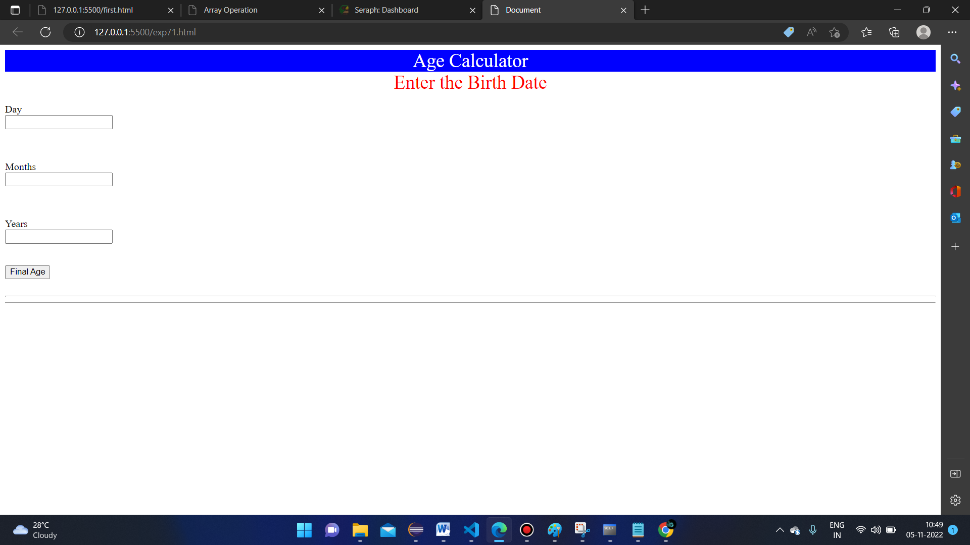

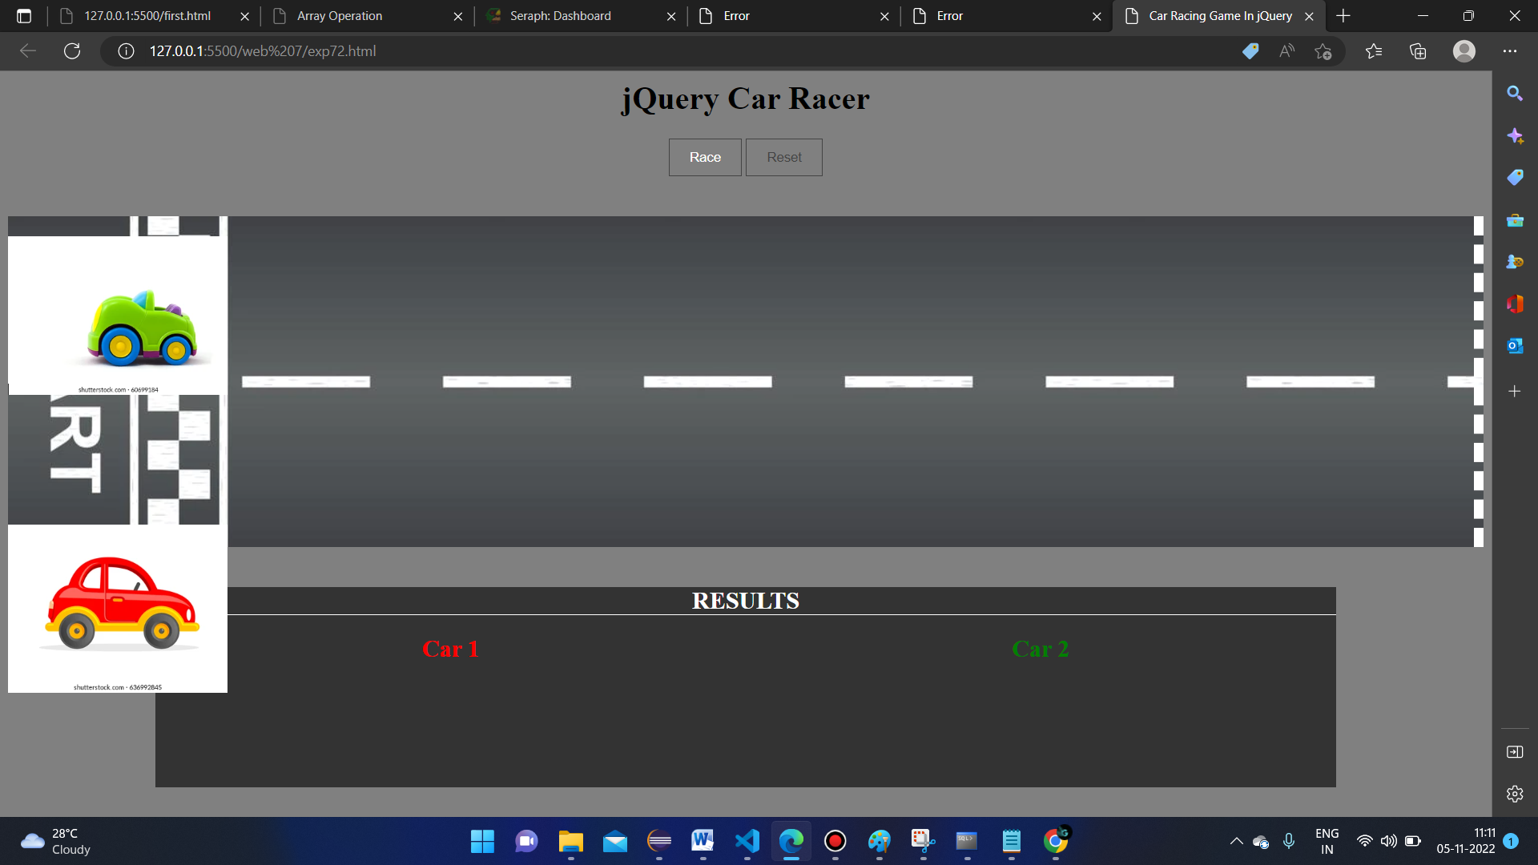

**Result**

Here we have done the web development using jquery Action frame work